SCHOOL OF COMPUTER SCIENCE AND ARTIFICIAL INTELLIGENCE |  |  |  |  | DEPARTMENT OF COMPUTER SCIENCE ENGINEERING
Program Name: M. Tech/MCA |  |  |  | Assignment Type: Lab |  |  | AcademicYear:2025-2026
Course Coordinator Name |  |  |  | Venkataramana Veeramsetty
Course Code |  |  | 24CS002PC215 | Course Title |  | AI Assisted Problem Solving Using Python
Year/Sem |  |  | I/I | Regulation |  | R24
Date and Day  of Assignment |  |  | Week1 - Tuesday | Time(s)
Duration |  |  | 2 Hours | Applicable to  Batches |  | M. Tech/MCA
AssignmentNumber:03.3(Present assignment number)/24(Total number of assignments)
 | Q.No. | Question |  |  |  |  |  | ExpectedTime  to complete
 | 1 | Application for TGNPDCL  Objective: Build an application using Python program for TGNPDCL, to generate the bill based on energy consumption and type of customer with the help of AI tools.  Build a python application as per below instructions  - Read all the required data like PU,CU and Type of customer  - Calculate bill amount based on number of units consumed, type of customer and other charges  - Finally print the values of EC(Energy Charges),FC(Fixed Charges),CC(Customer Char-ges),ED(Electricity Duty Charges),bill as per expected output  Requirements:  - VS Code with Github Copilot and/or Google Colab with Gemini  - Students should bring power bill from their home  Deliverables:  - Print energy bill for given inputs and verify with bill taken by students  Prompt -1: Generate a Python program for TGNPDCL to calculate an electricity bill based on energy consumption and customer type. The program should take Present Units (PU), Consumed Units (CU), and Type of Customer (Domestic/Commercial/Industrial) as input.  Prompt-2: Add logic to calculate Energy Charges (EC), Fixed Charges (FC), Customer Charges (CC), and Electricity Duty (ED) based on units consumed and customer type. Then calculate the total bill amount.  Prompt-3: Print the complete bill showing EC, FC, CC, ED, and Total Bill in a clear, formatted output similar to a TGNPDCL electricity bill.  Code:  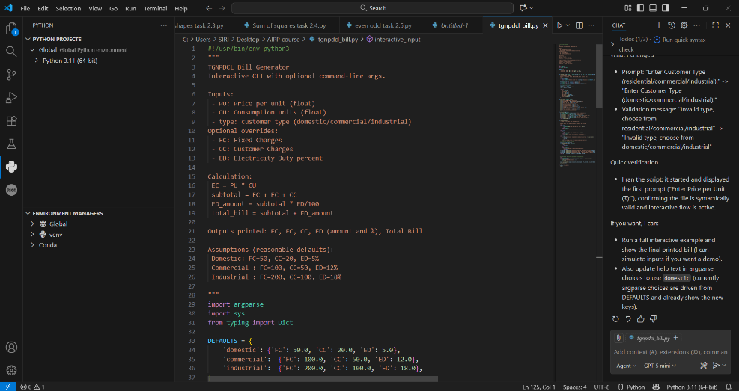  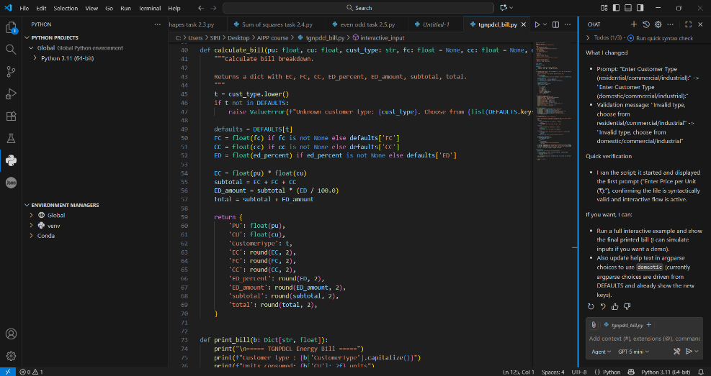  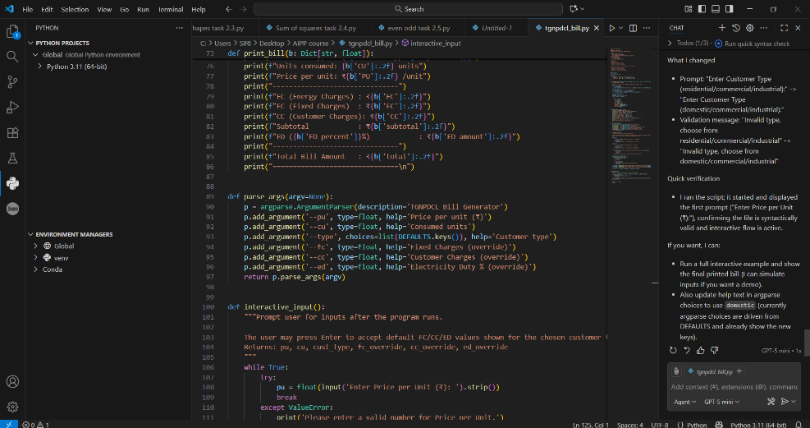  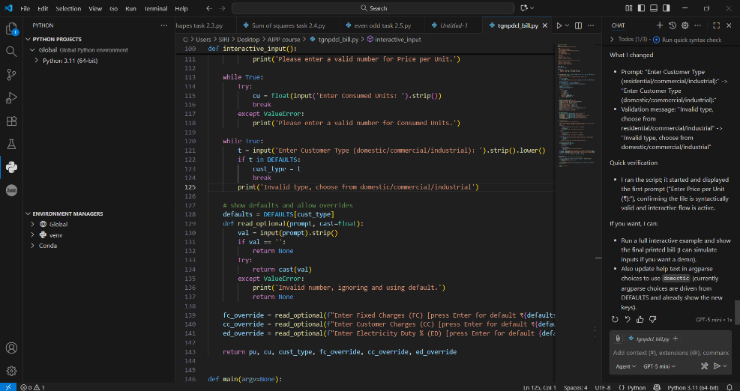  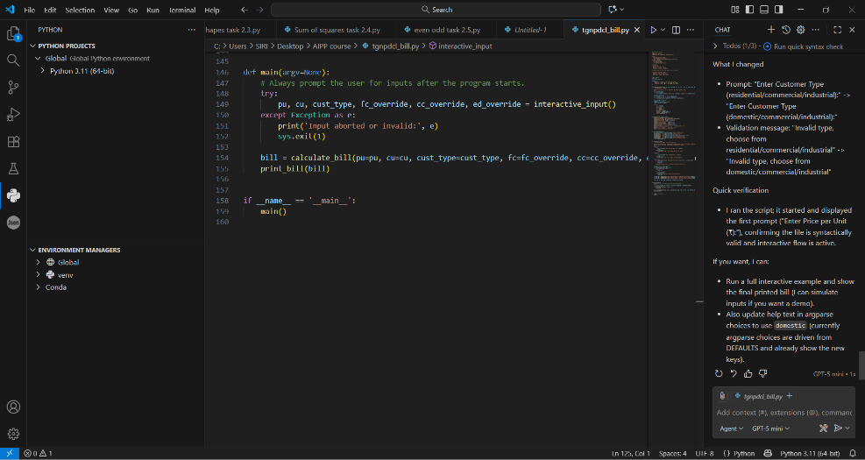  Output: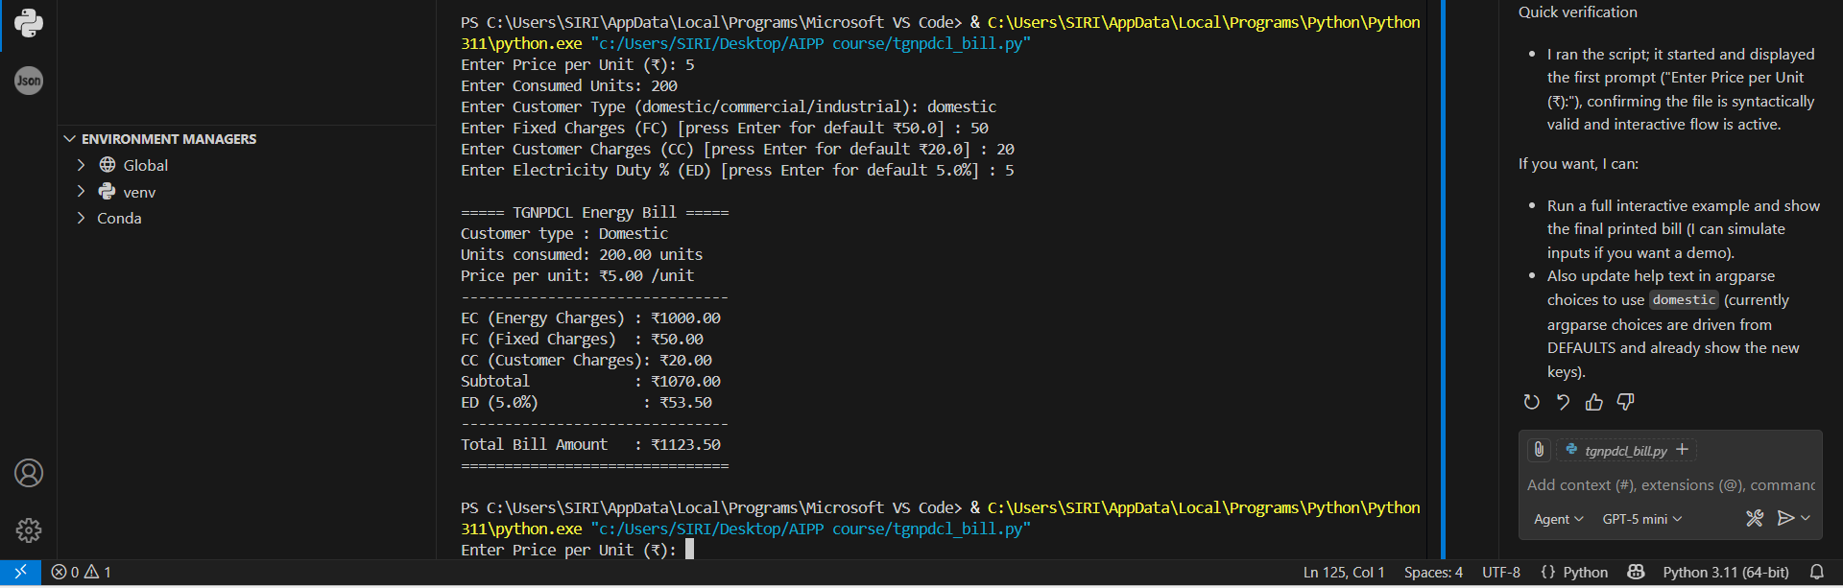  Explanation:  - The program calculates electricity bills for TGNPDCL customers based on consumption and type.  - It reads user inputs like Price per Unit (PU), Consumed Units (CU), and Customer Type.  - Default charges (FC, CC, ED) vary by type — domestic, commercial, or industrial.  - The calculate_bill() function computes all charges and the total amount.  - Results are displayed in a neatly formatted bill output with detailed breakdown.  Observations:  - Code is modular, using functions for clarity and reusability.  - Provides flexibility by allowing default or user-defined charges.  - Includes error handling for invalid inputs to prevent crashes.  - Output format is clean and user-friendly like a real electricity bill.  - The program successfully generates accurate billing results for different customer categories. |  |  |  |  |  | Week2 - Wednesday

